Motor Concept Explanation

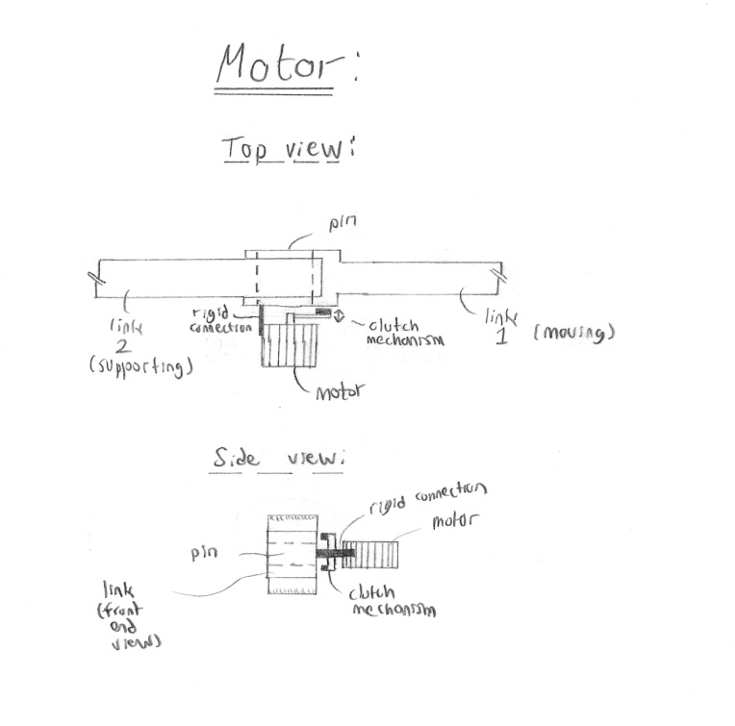

Another concept which has been generated to serve the function of the device staying stationary without input incorporates an active motor and engagement mechanism. The idea is to sense the link’s free-falling movement when the user removes their hand from the robot arm, or, equivalently, sense a removal of the users hand from holding the robot arm. In that instance, a motor is turned on to provide torque at the appropriate joint against that free-falling motion, and the torque is transferred to the joint using a clutch or brake mechanism. The beauty of the clutch or brake actuation is that it is not permanent, but is strong enough to provide sufficient retaining force through friction.

This concept has a few advantages and disadvantages associated with it. The main advantage with this concept is that it is bi-directional, meaning that whichever way the link without an input falls, a retaining force can act against it. Another advantage of this system is its quantifiable retaining capability, which is considered to be high compared to other concepts. It is enough to realize that brakes and clutches are used in many other applications which require a lot more torque. However, disadvantages of this concept are that it is complicated and expensive. The complication comes in the choice of motor and the design of a suitable actuation mechanism, along with the design of suitable mounting methods to the robot. In addition, it is definitely not the cheapest of concepts, mainly because it involves the purchase of a motor. In addition, the mechanism as a whole, with the motor itself, will probably add significant weight to the robot. Finally, this concept is an active system, meaning that it cannot operate without power. This can be a concern in power outages or even shortages in the operating room.

Counterweight Concept Explanation

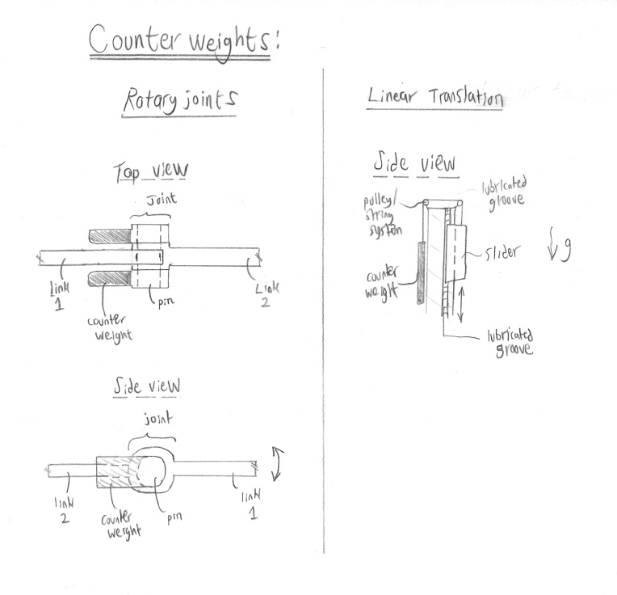

Quite a simple and intuitive solution to serve the function of the device staying stationary without input incorporates the use of counterweights on the moving robot arms. Both rotary and linear links can utilize such a concept, with a few slight differences between the two. The idea with a counterweight is to constantly provide a countering force, similar to that of the robot arm and the cutting tool, which immediately jumps into action when the input from the surgeon is removed. The system is passive, so it doesn’t require any power input. Also, the system is adjustable to different robot arms and different sizes and weight of tools

The main advantage of the counterweight system is that it is simple and inexpensive. The actual counterweight can be any high-density material and can almost be oriented in any position, so long as it provides a consistent and sufficient countering force when needed. The disadvantage of this system is that the weight of the robot arm is essentially doubled with the addition of the counterweight, thus making the overall robot weigh considerably more. In addition, “sterilizability” of this system is predicted to be a more difficult task than in other systems. This is due to the introduction of large areas of unsterile surfaces. Finally, a prominent disadvantage of this system is that the “virtual” weight of the robot arm is substantially increased. When working with the robot, the surgeon must apply a force to overcome the counterweight in addition to the force needed to do the initial cutting work.